Project Development Phase
Model Performance Test
Date | 29 September 2026
Team ID | SWTID-2026-4574
Project Name | Script-Controlled ACL – Restrict Record Access Based on Field Value
Maximum Marks | 10 Marks
Team Size | 3
Team Leader | LOGESHWARI K T
Team Member | ALJASIRA R
Team Member | KAVIYA N

Model Performance Testing:
Project team shall fill the following information in model performance testing template.
S.No | Parameter | Screenshot / Values
1. | ACL Configuration | Access Control rule configured for the Institution Details record; read access is controlled using the configured ACL condition/script.
2. | Field-Based Access Rule | Record access is evaluated using the Branch field value. Authorized users can access permitted records; restricted records are denied.  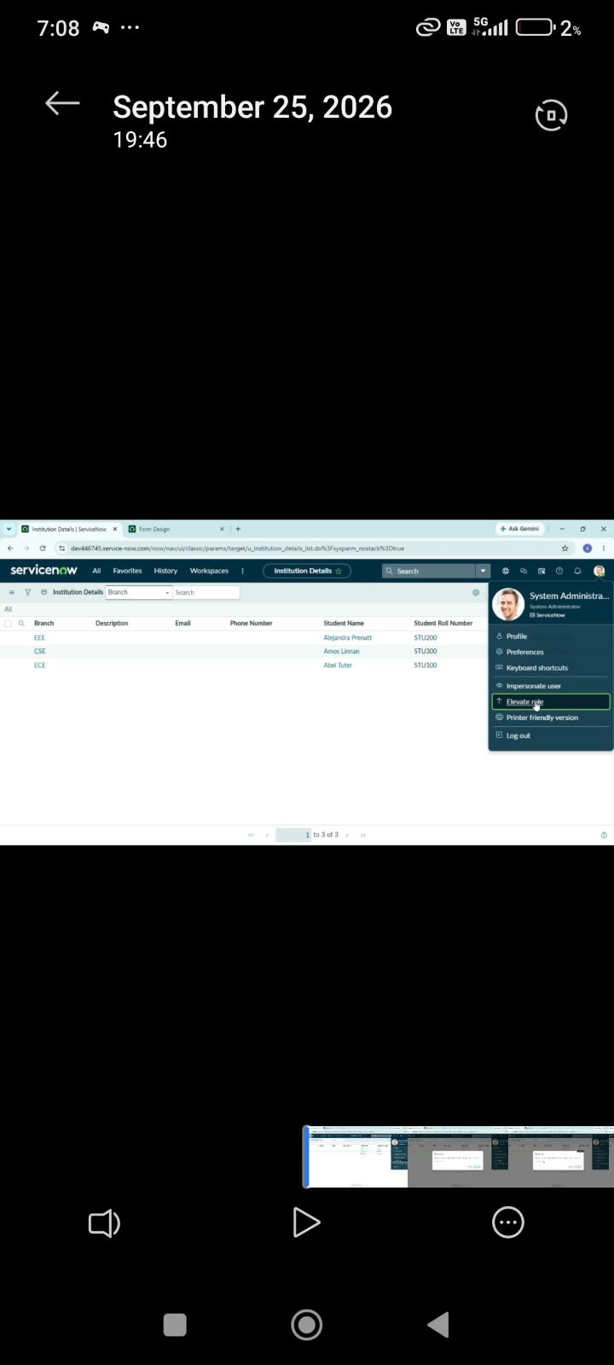
3. | Script Evaluation | Script-controlled condition evaluates the record field at request time and returns the appropriate allow/deny decision.  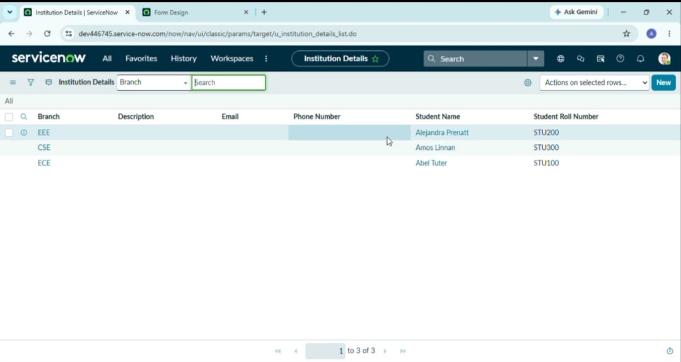
4. | Unauthorized Access Check | When the user does not satisfy the field-based condition, the protected record is not exposed.  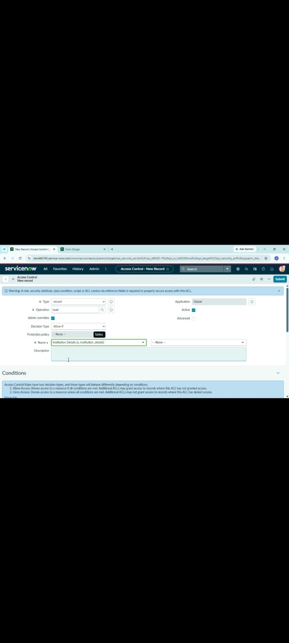
5. | Authorized Record Access | When the configured field value satisfies the rule, the requested record is available to the authorized user.  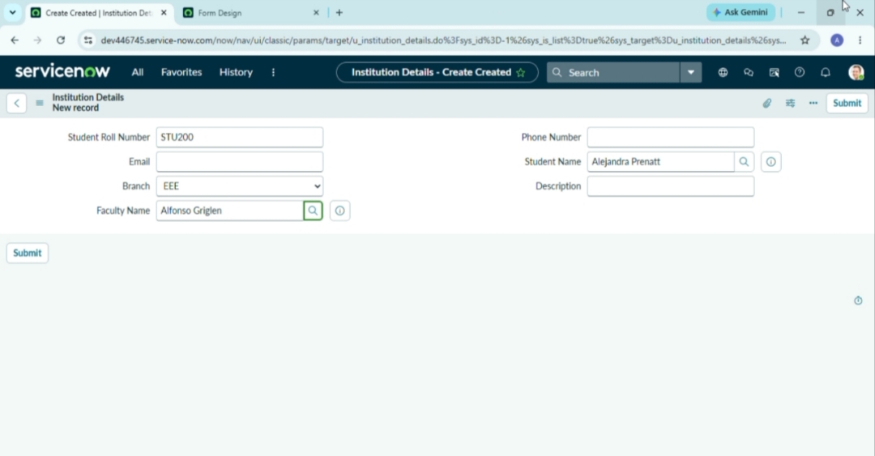
6. | ACL Performance / Validation | ACL behavior is validated using multiple field values and user contexts; access decision is applied consistently.

